Retailer Social Media Templates

- BUD Rule Facebook Post
Next time you make a paint purchase, remember the BUD rule!
Buy only the amount you need
Use what you buy
Drop off the leftovers for sharing or recycling

For more information on how to properly store your paint and what to do with the leftovers, check out this article.
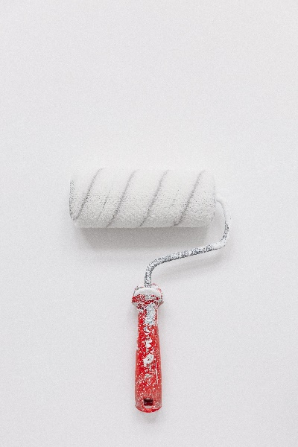 or 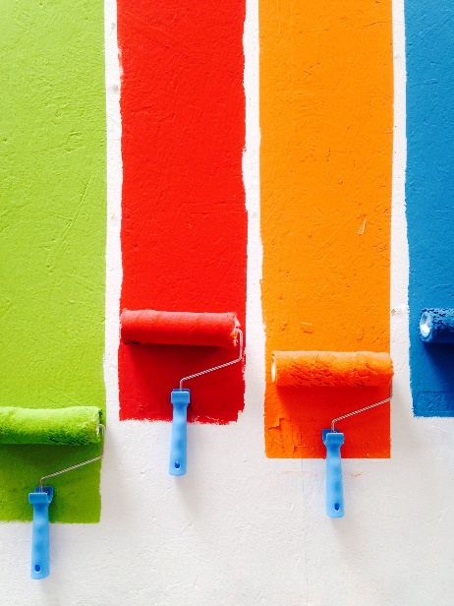
Photo by Yoann Siloine on Unsplash Photo by David Pisnoy on Unsplash

- BUD Rule Twitter Post
Next time you buy paint, remember BUD:
-Buy only the amount you need
-Use what you buy
-Drop off the leftovers
Get more information about how to properly store your paint, and what to do with the leftovers here.

- Recycling Locator Facebook or Twitter Post
Once you are finished with your latest renovation project, bring your paint back to one of many recycling locations near you! To find your closest location visit www.productcare.org/recycling-locator/
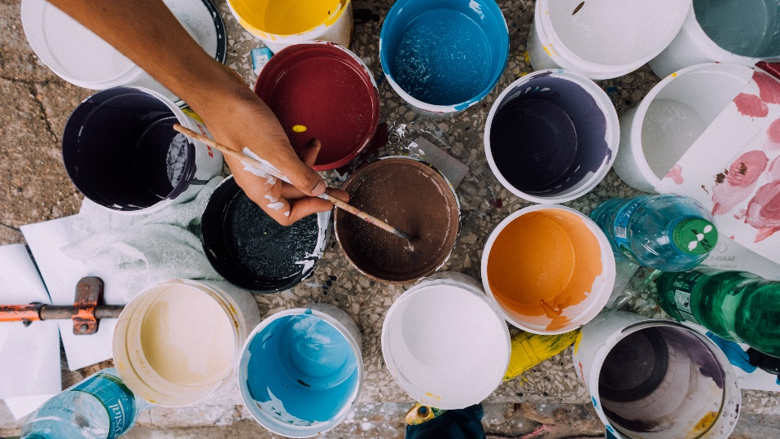
Photo by russn_fckr on Unsplash

- Product Lifecycle Facebook or Twitter Post
We care about all stages of a product’s lifecycle, including end-of-life. Protect your community and the planet by recycling your products once you no longer have a use for them. Check out this list of recycling programs near you.
Photo by Michael Fruehmann on Unsplash

